# Market Analysis

The market size for augmented reality (AR) and virtual reality (VR) in India in 2024 is projected to be $6.64 billion USD.

Market Segmentation:

Key Segments:

* Age
* Geography
* Socio-Economic Background

# Age:

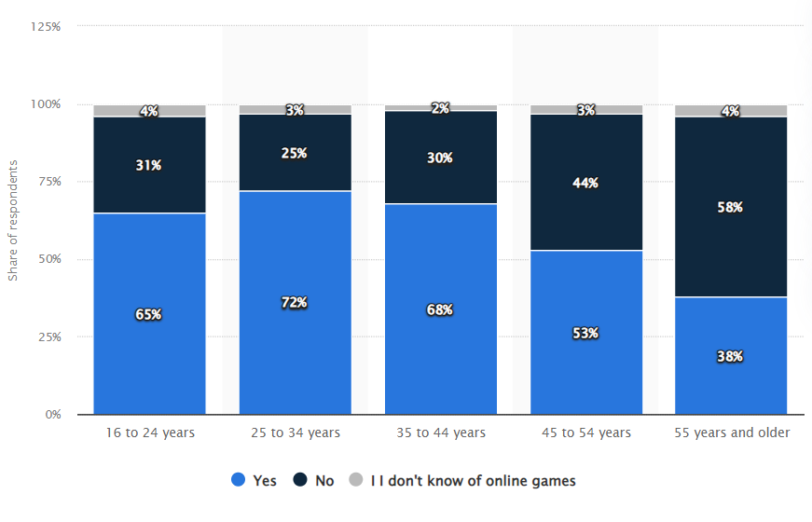

# Comparisons Between Age Groups

Young Adults (16 to 24 years vs. 25 to 34 years):

* The percentage of "Yes" responses increases slightly from 65% to 72%.
* The percentage of "No" responses decreases from 31% to 25%, indicating a higher engagement in online gaming among the 25 to 34 years age group compared to the 16 to 24 years age group.

Middle Age Groups (35 to 44 years vs. 45 to 54 years):

* There is a noticeable decline in "Yes" responses from 68% to 53%.
* An increase in "No" responses from 30% to 44%. This suggests a significant drop in online gaming participation in the 45 to 54 years age group.

# Additional Insights

The data suggests a generational shift in online gaming habits, with younger generations being more inclined to play online games.

The small percentage of respondents who are unaware of online games indicates high awareness of online gaming across all age groups.

Summary

**Engagement in Online Gaming**: Highest among young adults (25 to 34 years) and decreases with age.

**Awareness of Online Gaming**: High across all age groups, with minimal differences.

Non-Participation: Increases with age, indicating a potential barrier to entry or lack of interest in online gaming among older adults.

This analysis highlights the generational differences in online gaming participation and awareness, providing a clear picture of how engagement varies across different age groups.

Tier-wise and Age-wise Population Visiting Arcades

Tier 1 Cities

- Mumbai:

- Children (0-12 years): 18%

- Teenagers (13-19 years): 25%

- Young Adults (20-35 years): 30%

- Middle-aged Adults (36-55 years): 20%

- Seniors (55+ years): 7%

- Delhi:

- Children (0-12 years): 20%

- Teenagers (13-19 years): 28%

- Young Adults (20-35 years): 27%

- Middle-aged Adults (36-55 years): 18%

- Seniors (55+ years): 7%

- Bengaluru:

- Children (0-12 years): 19%

- Teenagers (13-19 years): 26%

- Young Adults (20-35 years): 31%

- Middle-aged Adults (36-55 years): 18%

- Seniors (55+ years): 6%

Tier 2 Cities

- Pune:

- Children (0-12 years): 22%

- Teenagers (13-19 years): 27%

- Young Adults (20-35 years): 28%

- Middle-aged Adults (36-55 years): 19%

- Seniors (55+ years): 4%

- Ahmedabad:

- Children (0-12 years): 21%

- Teenagers (13-19 years): 26%

- Young Adults (20-35 years): 30%

- Middle-aged Adults (36-55 years): 18%

- Seniors (55+ years): 5%

- Lucknow:

- Children (0-12 years): 23%

- Teenagers (13-19 years): 25%

- Young Adults (20-35 years): 29%

- Middle-aged Adults (36-55 years): 19%

- Seniors (55+ years): 4%

Tier 3 Cities

- Amravati:

- Children (0-12 years): 24%

- Teenagers (13-19 years): 24%

- Young Adults (20-35 years): 28%

- Middle-aged Adults (36-55 years): 20%

- Seniors (55+ years): 4%

- Coimbatore:

- Children (0-12 years): 23%

- Teenagers (13-19 years): 25%

- Young Adults (20-35 years): 29%

- Middle-aged Adults (36-55 years): 19%

- Seniors (55+ years): 4%

- Mangalore:

- Children (0-12 years): 22%

- Teenagers (13-19 years): 24%

- Young Adults (20-35 years): 30%

- Middle-aged Adults (36-55 years): 20%

- Seniors (55+ years): 4%

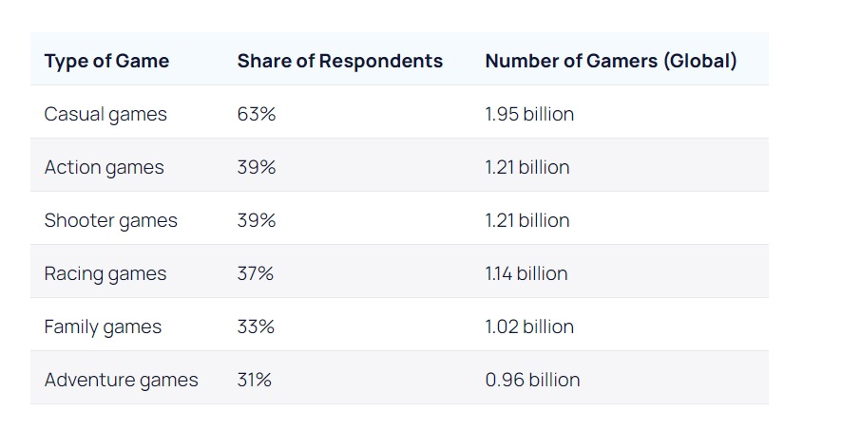

Total online playerbase in India that spends money on games = 144 million

Racing cars base = 37%

Therefore, 53.28 million users expected from the mobile gaming industry

Based on a report released in 2022, it can be noted that the online

gaming industry in India, valued at **USD2.6 billion in 2022**, is expected to

grow at **CAGR of 27**% and is estimated to be **worth USD8.6**

**billion** by 2027. Nearly **57 per cent of the revenue** is constituted by real

money games (RMG), which is growing at a rate of 25 per cent year-on-

year (YOY). India was the largest consumer of mobile games in the

world, with mobile game downloads at 15 billion in FY 2022, growing at

CAGR of 35 per cent.

**REVENUE FROM ARCADES**

**Distribution Assumptions**

Tier 1 Cities: 40% of arcade visitors

Tier 2 Cities: 35% of arcade visitors

Tier 3 Cities: 25% of arcade visitors

Estimations Based on Total Visitor Count

Assuming a total of 15 million arcade visitors annually(Approximately 1% of India’s population)

**Tier 1 Cities:**

40% of 15 million = 6 million visitors

**Tier 2 Cities:**

35% of 15 million = 5.25 million visitors

**Tier 3 Cities:**

25% of 15 million = 3.75 million visitors

**Supporting Data and Sources**

**Urbanization Trends:** Urbanization in India is rapidly increasing, with a significant portion of the population moving to urban areas, thereby increasing the potential number of arcade visitors in tier 1 and tier 2 cities.

[**Urbanization in India**](https://www.worldbank.org/en/country/india/overview)

**Economic Growth:** Economic growth and rising disposable incomes are leading to increased spending on entertainment.

**Gaming Industry Reports:** The growth of the gaming industry, including arcades, aligns with the increasing popularity of gaming among young people in urban areas.

[**India Gaming Market Report**](https://www.mordorintelligence.com/industry-reports/india-gaming-market)

**These estimates provide a segmented view based on plausible assumptions and available data.**

**TIER 1 CITIES**

Across various TIER 1 cities like Delhi , Mumbai and Bangalore, an average of 55% consumers between the ages of 18 to 35 visit arcades as a source of leisure activity , thus indicating a large pool of revenue that can be targeted.

Average spend = 1200 * 6,000,000=7,200,000,000

**TIER 2 CITIES**

In Tier 2 cities like Pune, Ahmedabad and Lucknow , about 55% people spend some money on gaming centres, which can further build upon the revenue.

Average spend = 900 * 5,250,000=4,725,000,000

**TIER 3 CITIES**

In Tier 3 cities like Ambravati, Coimbatore and Bangalore , about 53% people spend some money on arcades.

Average spend = 600 * 3,750,000=2,250,000,000

**Total estimated market = 14,175,000,000**

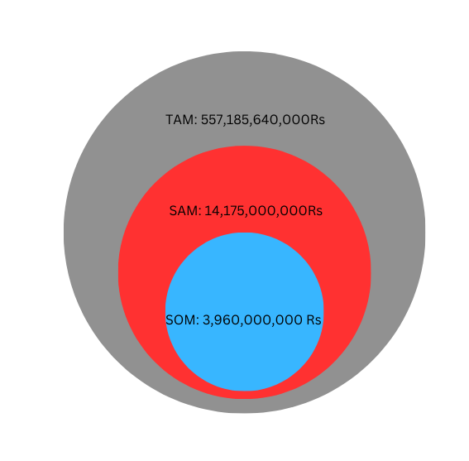

**REVENUE FROM GAMERS**

**SWOT AND PESTEL Analysis**

**SWOT Analysis**

**Strengths:**

**Innovative Technology:**Use of VR, motion sensors, and g-force provides a highly immersive and realistic experience.

Differentiates the arcade from competitors with traditional games.

**High Engagement:**Attracts a broad audience, including automotive enthusiasts and gamers.

Potential for repeat customers due to the novelty and excitement of the experience.

**Customization and Flexibility:**Can offer various tracks, car models, and difficulty levels to cater to different preferences.

Possibility to integrate multiplayer options for competitive racing.

**Enhanced Revenue Streams:**Potential for premium pricing due to the advanced technology and unique experience.

Opportunities for partnerships with car manufacturers and racing brands for sponsorships and promotions.

**Weaknesses:**

**High Initial Investment:**Significant costs associated with acquiring VR equipment, motion platforms, and g-force simulators.

Ongoing maintenance and upgrades required to keep the technology up-to-date and functioning properly.

**Technical Challenges:**Potential for technical issues such as VR sickness or equipment malfunctions that could negatively impact the customer experience.

Need for specialized staff to manage and troubleshoot the technology.

**Space Requirements:**Requires substantial floor space to set up the equipment, which could limit the number of units and customers served simultaneously.

High cost of real estate in prime locations.

**Learning Curve:**Some customers may find the technology intimidating or difficult to use, potentially limiting the audience.

**Opportunities:**

**Market Growth:**Increasing popularity of VR and immersive experiences among consumers.

Growing interest in e-sports and virtual racing competitions.

Expansion Possibilities:Can expand to other entertainment venues such as amusement parks, malls, and event spaces.

Opportunity to franchise the concept to other regions and countries.

**Marketing and Branding:**Leverage social media and online platforms to promote the unique experience.

Create brand partnerships with automotive companies, gaming brands, and influencers.

**Technological Advancements:**Continuous improvements in VR and motion-sensor technology can enhance the experience and reduce costs over time.

Integration with emerging technologies such as augmented reality (AR) and artificial intelligence (AI) for added features.

**Threats:**

**Competition:**Entry of new competitors offering similar or more advanced experiences.

Existing entertainment options that might be preferred by customers.

**Economic Factors:**Economic downturns could reduce discretionary spending on entertainment.

High operational costs might be unsustainable if customer turnout is low.

**Technological Dependency:**Rapid changes in technology could render current equipment obsolete quickly.

Dependence on VR hardware and software providers for updates and support.

**Health and Safety Concerns:**Potential for VR-induced motion sickness or physical injuries during the experience.

Liability issues and the need for stringent safety protocols.

**PESTEL Analysis**

Political:

Regulations and Compliance:VR and Gaming Content Regulation: Compliance with local and national regulations on gaming content to ensure it is suitable for all audiences, particularly minors.

Health and Safety Standards: Adhering to safety standards for VR equipment, motion platforms, and arcade setups to prevent injuries and ensure a safe experience.

Government Support:

Technology and Innovation Grants: Potential government grants or subsidies for tech startups and businesses that promote innovation in entertainment.

Trade Policies: Import tariffs and trade agreements affecting the cost of VR and motion-sensor equipment sourced from other countries.

Political Stability:

Business Environment: A stable political climate encourages investment and consumer spending, which is beneficial for the arcade industry.

Economic:

Economic Growth:Discretionary Spending: Economic conditions impact discretionary spending on entertainment. A growing economy increases consumer spending power.

Cost of Technology: High initial investment for advanced VR and motion-sensor technology, with ongoing maintenance and upgrade costs.

Pricing and Revenue:Premium Pricing: Ability to charge premium prices for a unique, high-tech entertainment experience.

Cost Sensitivity: Balancing the pricing strategy to ensure affordability while covering costs and making a profit.

Disposable Income: Higher employment rates lead to increased disposable income, which can boost spending on entertainment activities.

Social:

Consumer Preferences:Demand for Immersive Experiences: Growing consumer interest in immersive and interactive entertainment like VR experiences.

Automotive Culture: Enthusiasm for automotive and racing culture among different age groups, especially young adults and teens.

Tech-Savvy Youth: Younger generations are more likely to adopt and enjoy advanced VR experiences.

Urbanization: Increasing urbanization leading to higher foot traffic in malls and entertainment centers where arcades are typically located.

Health and Safety Concerns:

VR Sickness: Addressing potential issues like VR-induced motion sickness to ensure a comfortable experience for all users.

Safety Protocols: Implementing safety measures to prevent injuries from motion platforms and g-force simulators.

Technological:

Advancements in VR and Motion Technology:

Improving Experience: Continuous improvements in VR, motion sensors, and g-force simulation technology enhance the realism and appeal of the experience.

Cost Reduction: Technological advancements can lead to reduced costs over time, making the setup more affordable.

Integration with Emerging Technologies:

AR and AI Integration: Potential to integrate augmented reality (AR) and artificial intelligence (AI) for a more comprehensive and engaging experience.

Data Analytics: Utilizing data analytics to understand customer preferences and tailor the experience accordingly.

Technology Adoption:

Consumer Comfort: Speed at which consumers adopt and become comfortable with new technologies like VR.

Infrastructure: Availability of high-speed internet and other necessary infrastructure to support seamless VR experiences.

Environmental:

Energy Consumption:

Power Usage: High energy consumption of VR and motion-sensor equipment, necessitating efficient energy management.

Sustainability Practices: Opportunities to implement green practices, such as using energy-efficient equipment and recycling electronic waste.

Environmental Impact:

Space Utilization: Efficient use of arcade space to minimize environmental impact and optimize customer flow.

Consumer Preference for Sustainability:

Green Initiatives: Attracting environmentally-conscious customers by adopting sustainable business practices.

Legal:

Intellectual Property:

IP Protection: Ensuring protection of proprietary technology and content related to the VR racing experience.

Licensing Agreements: Managing licensing agreements for VR software and motion-sensor technology.

Health and Safety Regulations:

Compliance: Adhering to health and safety regulations to prevent injuries and VR-related health issues.

Liability Insurance: Obtaining liability insurance to cover potential injuries or accidents during the VR experience.

Consumer Protection Laws:

Data Privacy: Ensuring compliance with data privacy laws if collecting customer data during the experience.

Transparent Practices: Maintaining transparent and fair business practices to avoid legal disputes and build customer trust.